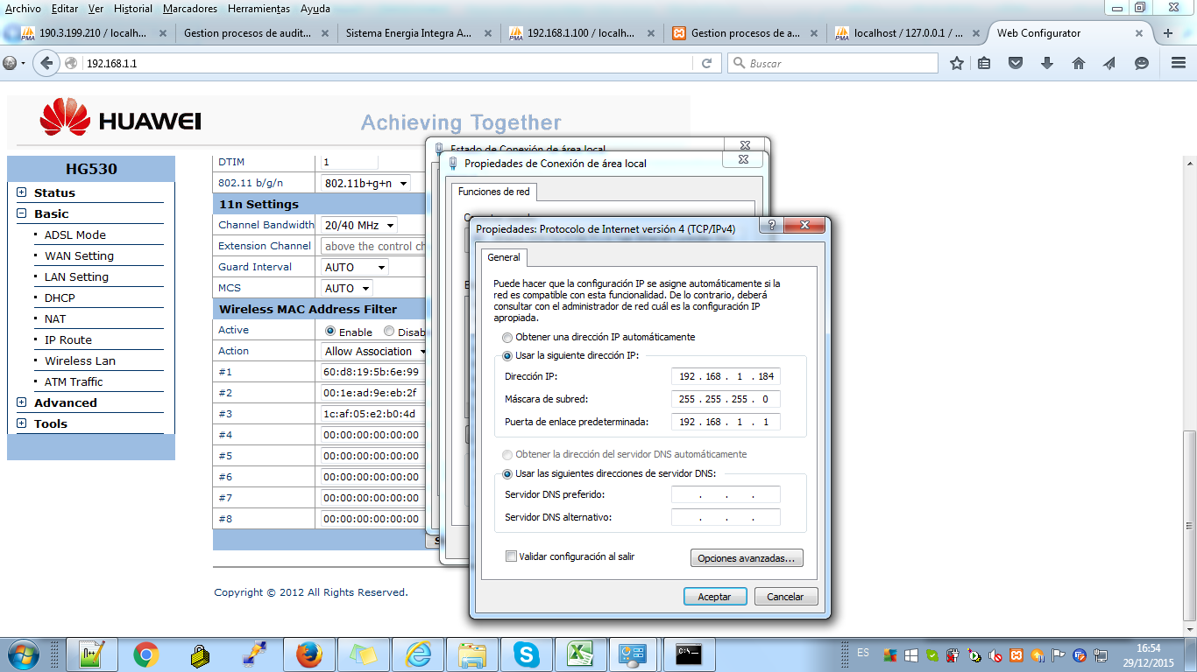

<http://192.168.1.1>

admin

CPE#023643